# The idea of the project

A company named cuisine that sells spices cubes for Yemeni dishes.

# User interface

1. A link that Redirects the user to the homepage of the website.
2. A link that Redirects the user to a page which contains latest news.
3. A link that Redirects the user to a page where he can interact with a form to get news emails and check our location on a map and see our social media websites.
4. A link that Redirects the user to a page which has different topics about the company.
5. A link that Redirects the user to a page to shop and buy products we offer.
6. A link that redirects the user to a page which lets the user to login or register.

1 2 3 4 5 6

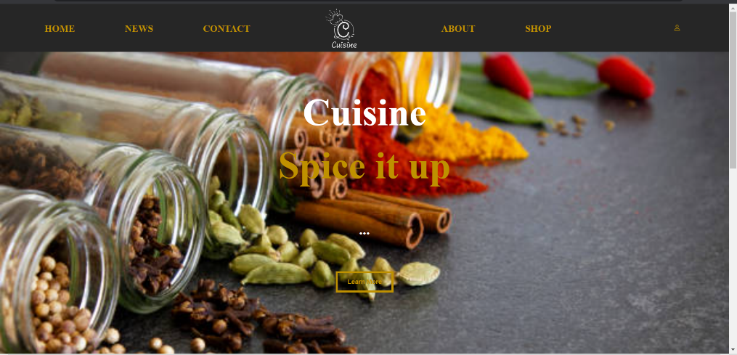

# Admin interface

1. A link that Redirects the user to the homepage of the website.
2. A link that Redirects the user to a page which contains latest news.
3. A link that Redirects the user to a page where he can interact with a form to get news emails and check our location on a map and see our social media websites.
4. A link that Redirects the user to a page which has different topics about the company.
5. A link that Redirects the admin to a page in which he can manage the website like adding, editing, searching or deleting a product.
6. A link that redirects the user to a page which lets the user to login or register.

1 2 3 4 5 6

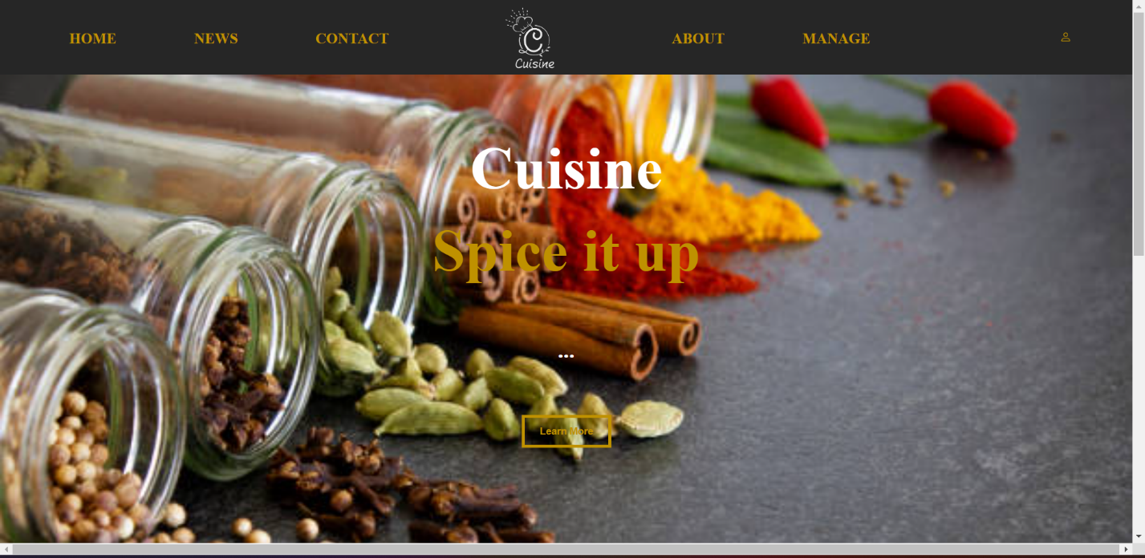

# The login form

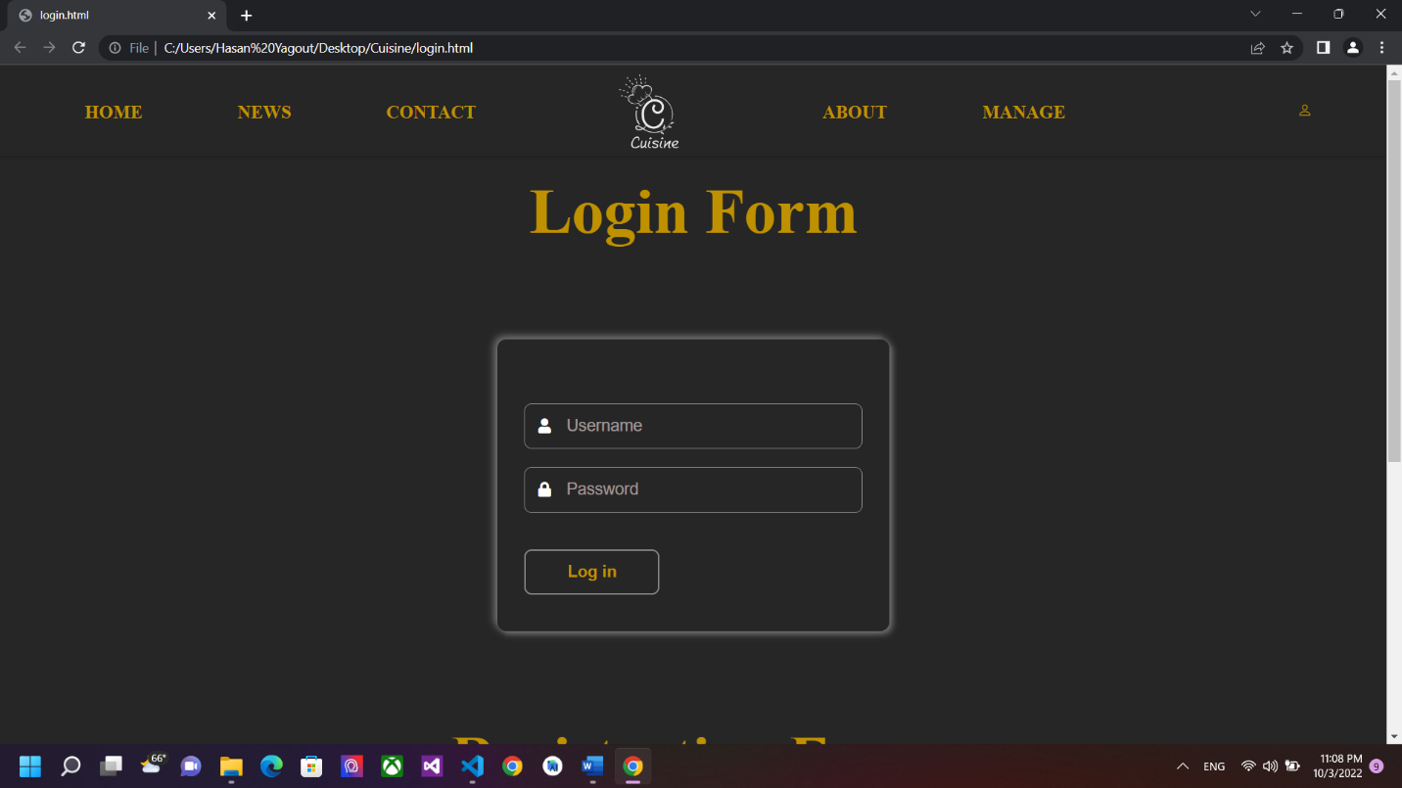

# The Registration form

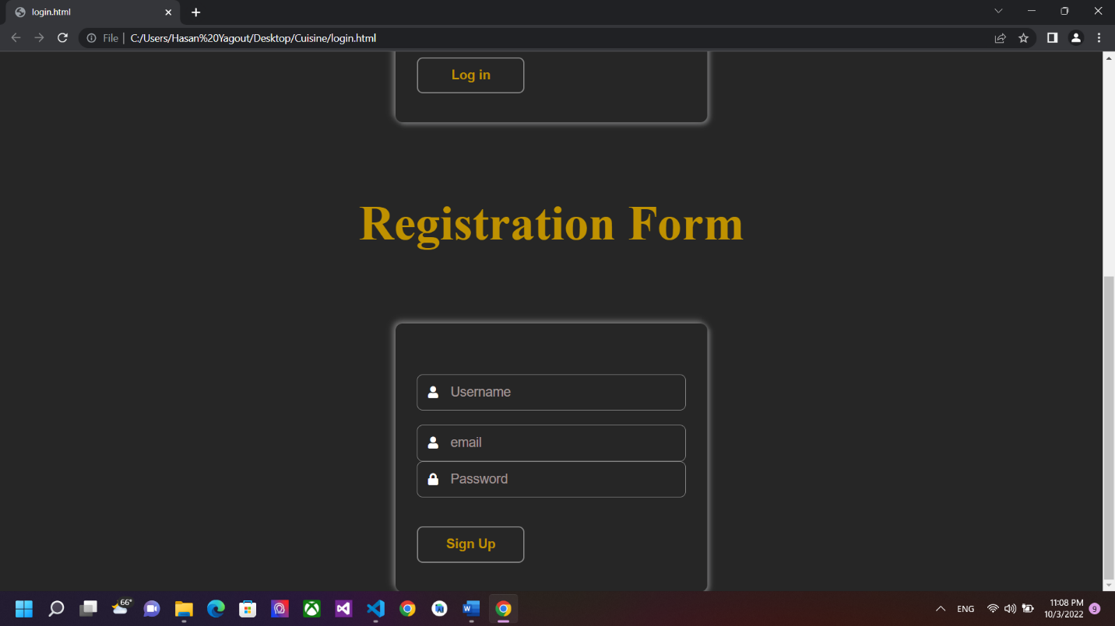

# The admin managing page

